AI FAQ Assistant
Date | 29 September 2026
Team Id | 6ab4cdb46603573ccfb546d2
Project Name | AI FAQ ASSISTANT API
Maximum Marks | 5 marks

Step1:Submission Checklist

S.No | Submission Item | Project Status
1 | Complete source code | Available
2 | README / Setup Guide | Available
3 | Dependency file | package.json + package-lock.json
4 | Database schema | User.js + FAQ.js
5 | Environment configuration | .env exists; use .env.example for sharing
6 | Deployed URL | Not supplied
7 | Executable binary | Not applicable — Node.js API
8 | Dockerfile | Not supplied
9 | Tests / results | test_api.js + Postman collection
10 | Demo video | Not supplied
The supplied reference requires organized runnable/deployable files and clear evaluator instructions.
■filecite■turn0file1■L7-L25■

Step 2:File / Folder Structure

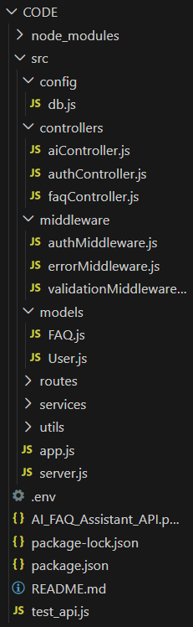

Step 3:Deployment / Access Details

Field | Details
Hosted / Deployed URL | Not supplied / not configured
Login Credentials | No fixed demo credentials; registration creates users
Platform / Hosting Provider | Not specified
Repository Link | Not supplied
Demo Video Link | Not supplied
The supplied reference includes these deployment/access fields; values are marked as not supplied because they are absent from the inspected project source. ■filecite■turn0file1■L30-L41■

Step 4:Run Instructions

Step 1 — Install prerequisites
Install Node.js 18+ or 20+ and make MongoDB available locally or through MongoDB Atlas.

Step 2 — Install dependencies
npm install

Step 3 — Configure environment
PORT=5000
MONGO_URI=mongodb://127.0.0.1:27017/ai_faq_assistant JWT_SECRET=your_secure_secret GEMINI_API_KEY=your_gemini_api_key

Step 4 — Start
npm start
# Development npm run dev

Step 5 — Verify
http://localhost:5000/

Run the integration test with:
node test_api.js
The AI tests explicitly handle both successful responses and correctly formatted API-key-related failures. The test source should be executed in the target environment before final submission to record actual results.

Step 5:Known Issues / Limitations

S.No | Known Issue / Limitation | Workaround / Status
1 | No deployed URL is included. | Deployment URL is not available in the supplied project.
2 | No Dockerfile is included. | Docker-based deployment is not provided.
3 | No separate frontend is included. | The project is backend/API focused.
4 | Gemini endpoints require GEMINI_API_KEY. | Configure the key before using AI endpoints.
5 | MongoDB must be reachable. | Configure MONGO_URI and ensure MongoDB is accessible.
6 | .env should not be redistributed with real secrets. | Keep credentials private.
7 | No demo video is included. | Add a demo video separately if required.

